|  |  |
| --- | --- |
| Name | Eman Mohamed El-Sayed Fatooh |
| B.N | 231 |
| Sec | 10 |
| Topic | Programming Languages |

Application Brief : A **programming language** is a [formal language](https://en.wikipedia.org/wiki/Formal_language) comprising a set of [strings](https://en.wikipedia.org/wiki/Formal_language#Words_over_an_alphabet) that produce various kinds of [machine code output](https://en.wikipedia.org/wiki/Machine_code). Programming languages are one kind of [computer language](https://en.wikipedia.org/wiki/Computer_language), and are used in [computer programming](https://en.wikipedia.org/wiki/Computer_programming) to implement [algorithms](https://en.wikipedia.org/wiki/Algorithm).

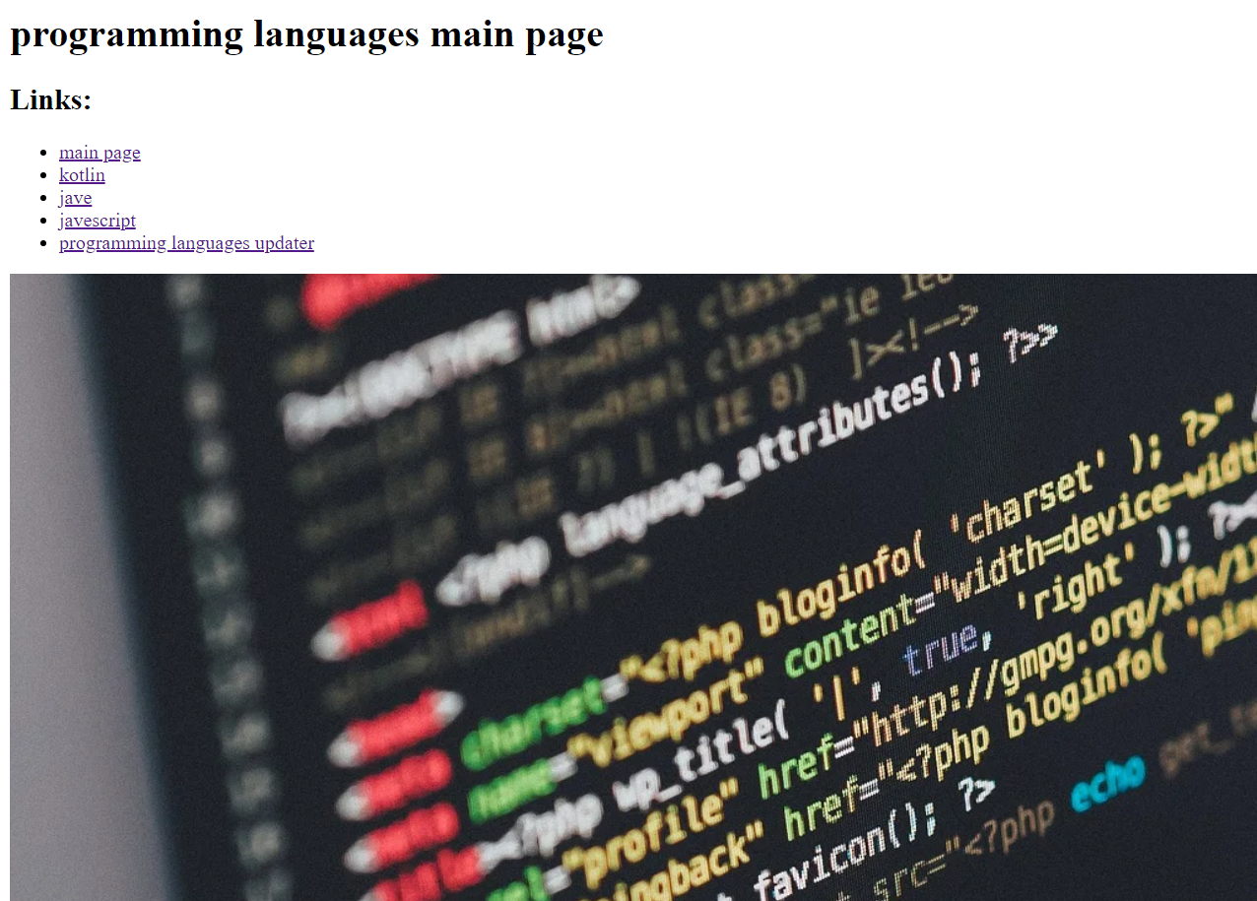***Scereenshots***:

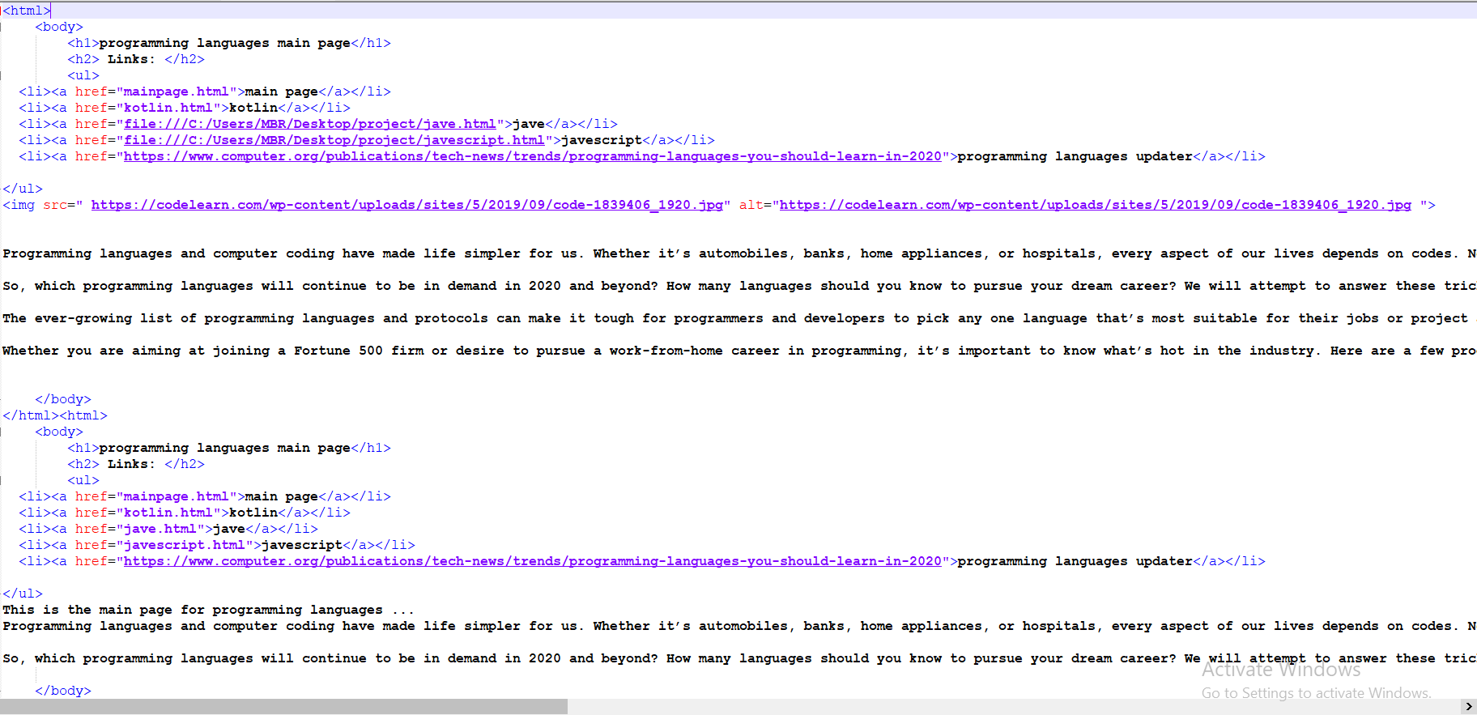

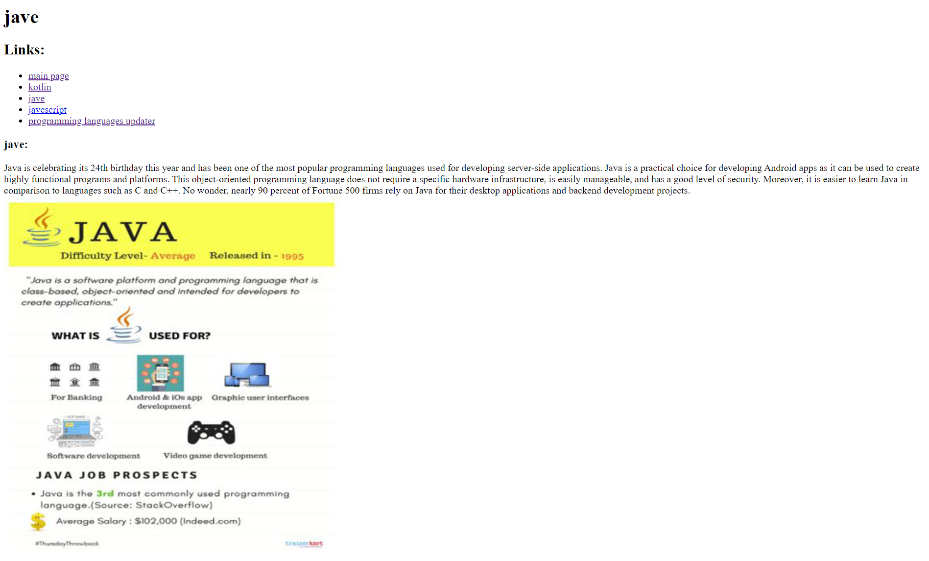

Source Code :

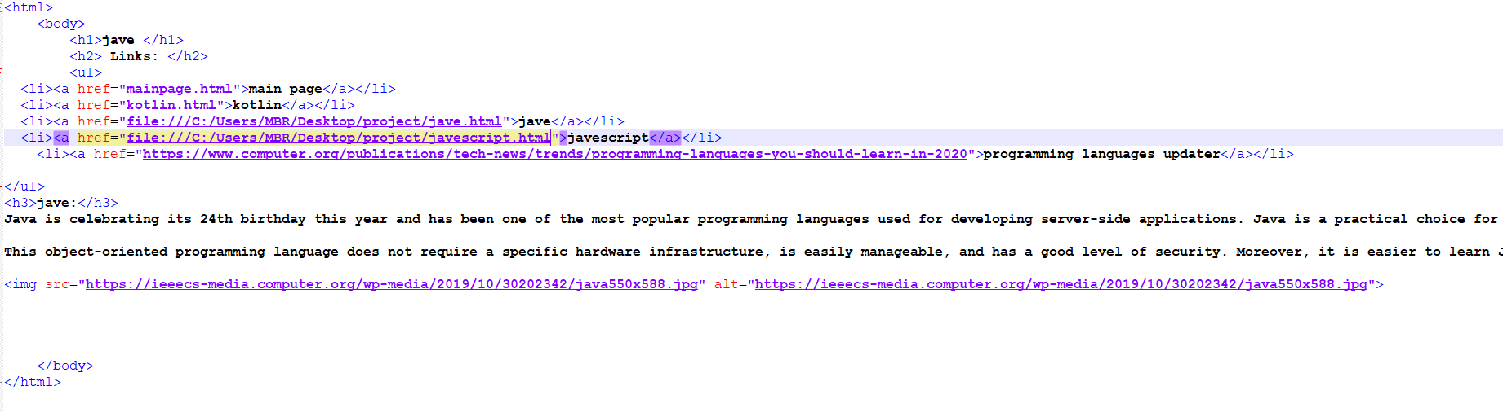

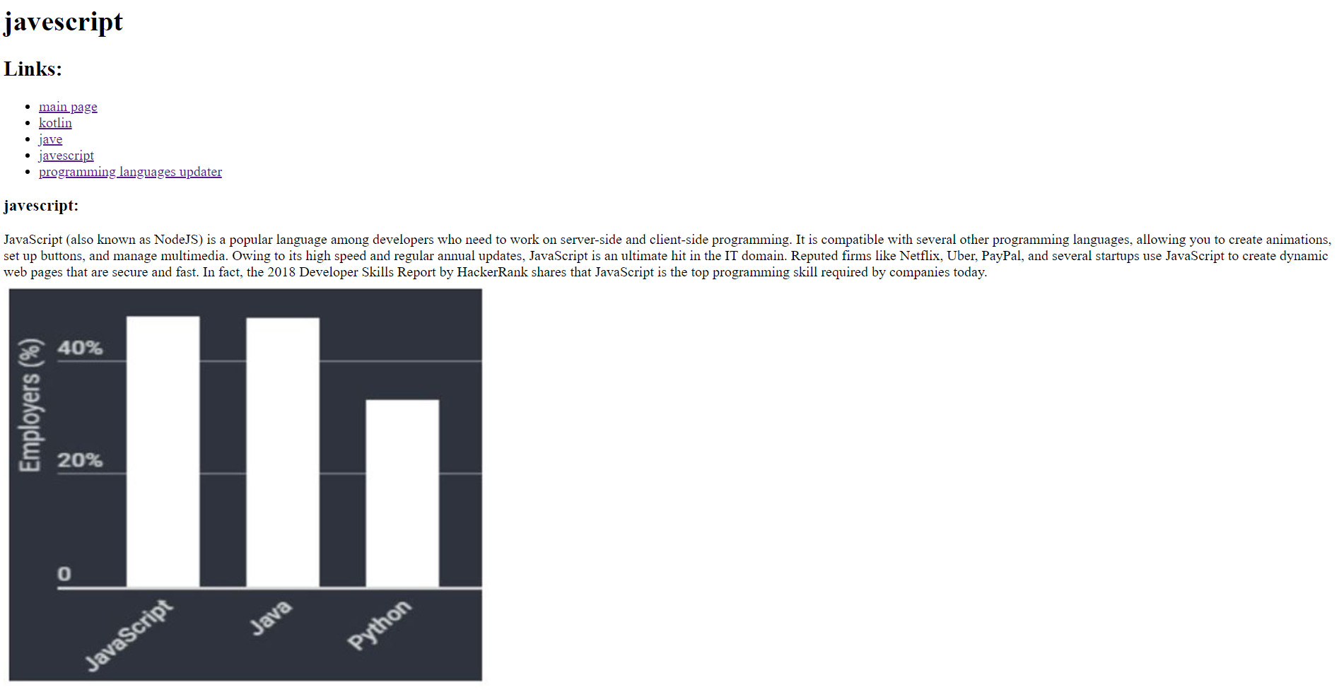

Source Code :

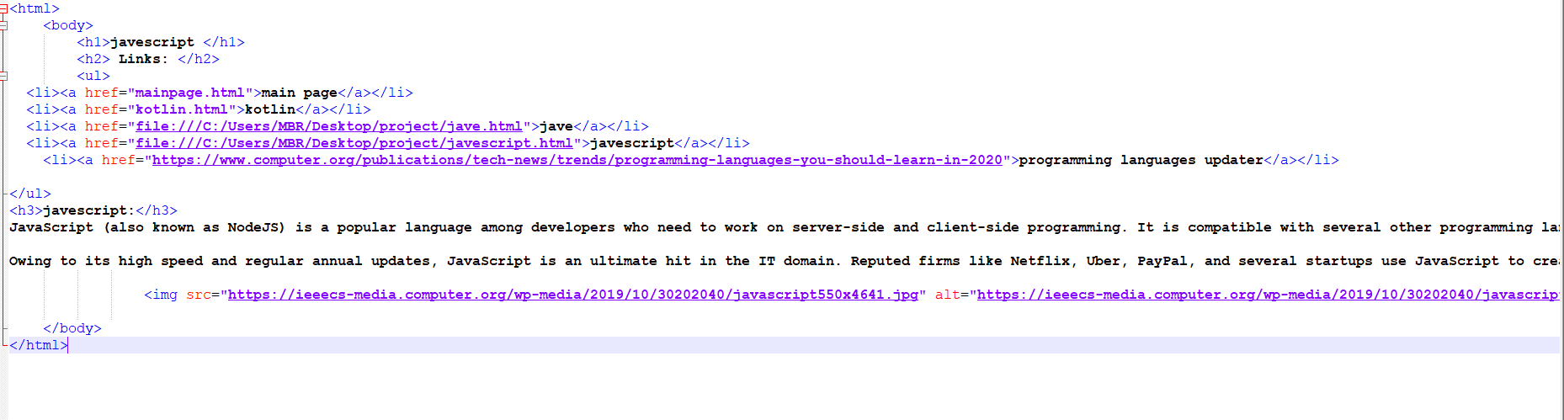

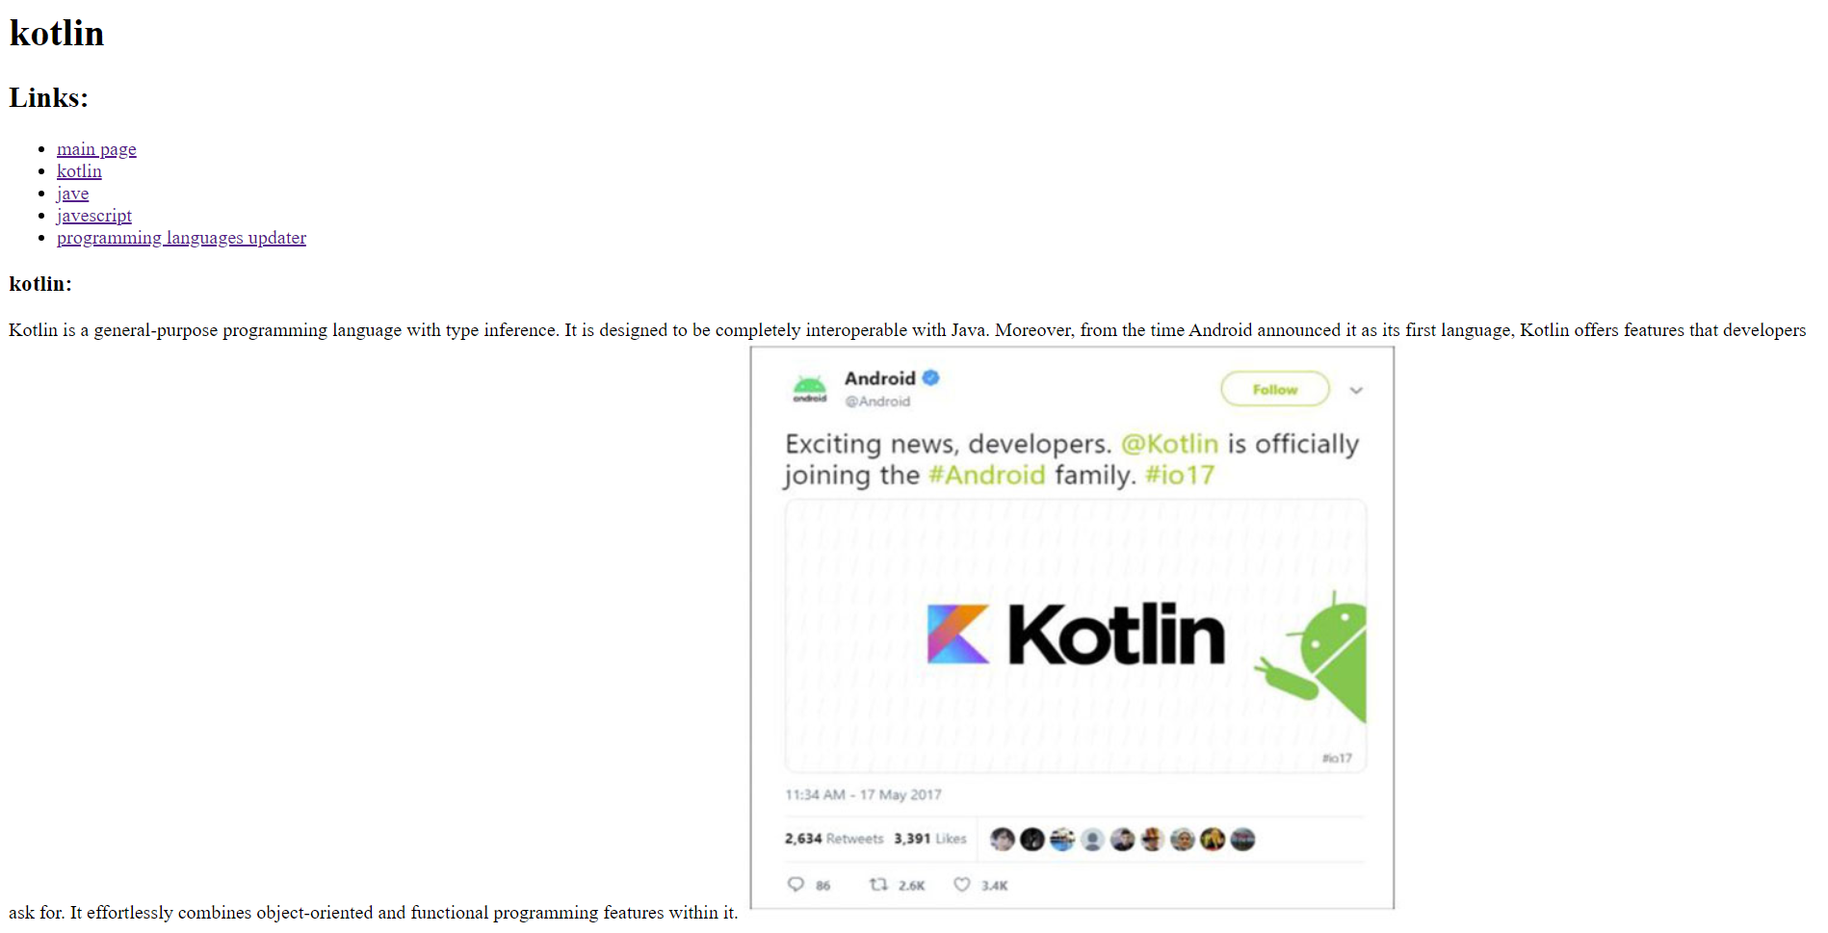

Source Code :

